**ASSIGNMENT - B1**

1. Show by definition:

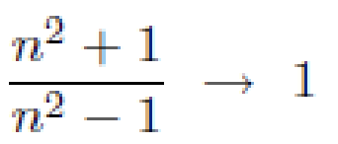

1. Find limit of the following sequence:
2. Test the following series for convergence:

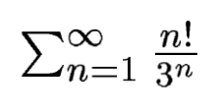

1. Discuss the convergence of the following series. Find about absolute convergence and conditional convergence.

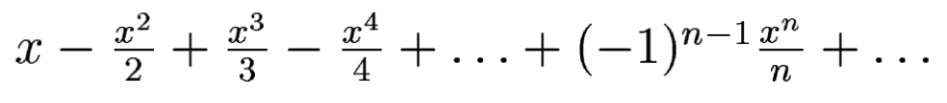

1. Find whether the following sequence of function is point-wise convergent on the given interval I. If so, decide whether they are uniformly convergent.

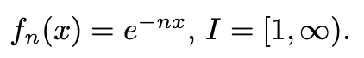

1. Find the interval of convergence for the following power series.

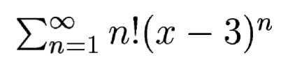

1. Prove the following:

- +

1. Find f (34) from the following data given using appropriate interpolation method

|  |  |  |  |  |  |  |
| --- | --- | --- | --- | --- | --- | --- |
| x | 20 | 25 | 30 | 35 | 40 | 45 |
| f(x) | 354 | 332 | 291 | 260 | 231 | 204 |

1. Evaluate $\int_{0}^{π}{t e^{t} dt}$ using the Trapezoidal rule with 4 and 6 subintervals. Find the absolute error comparing with exact solution.
2. Evaluate $\int_{1.0}^{1.6}{\sqrt{x}}$ dx using 1/3rd Simpson’s rule taking 6 subintervals.